Context free grammar can be used to represent context free lang

For CFG

LHS -> One non terminal or variable may be present

RHS -> (V U T)*

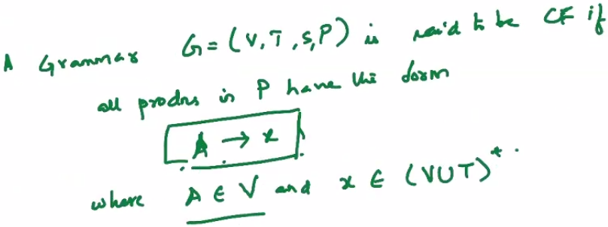

A lang L is said to be context free iff exists a CFG G such that L = L(G)

**Every regular grammar is a context-free grammar**

Eg

1. L = {a^n. b^n}

Here we can choose 2 productions such that

S -> aSb/lambda

S -> lambda

L(G) = {ab, aabb, aaabbb ... }

These productions are non-linear in nature, and so the grammar is context-free but not regular.

1. L(G) = ww^r : w belongs to {a,b}*

G = {{s}, {a,b}, S, P}

Productions P

S -> aSa

S -> bSb

S -> lambda

L = {lambda, aa, bb, abba ...}